Market Lamb and Goat Supplies

**General Supplies:**

1 or 2- Nylon Rope Halter

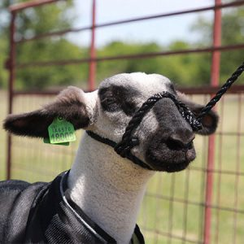 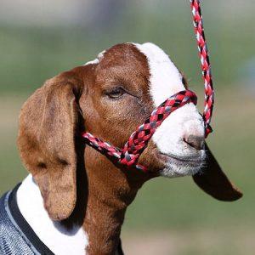

1- Mesh Muzzle (I prefer the adjustable strap over the elastic)

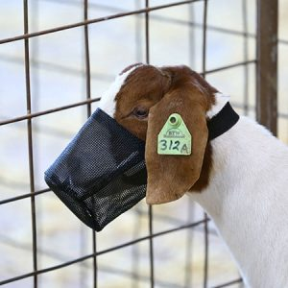 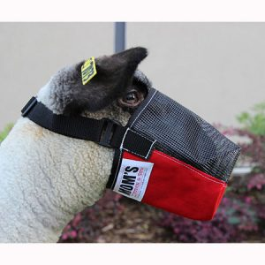

Blanket (size will vary based on the animals size)

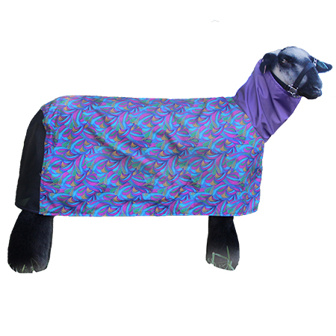 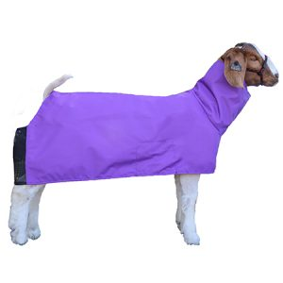

**Lamb blankets will NOT have an opening on rear-end for tail, goat blanket WILL

1 – Show Chain (NO SPIKES) -OR/AND- Halter (Goats Only)

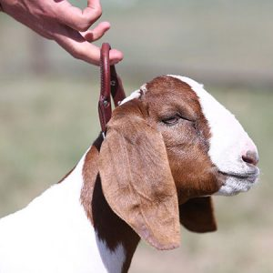 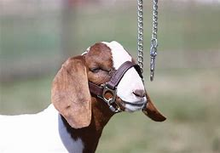

1- Clip on Feeder

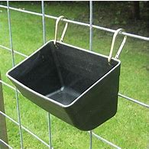 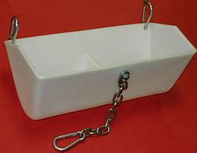

1 or 2 – Bucket (2 gal)

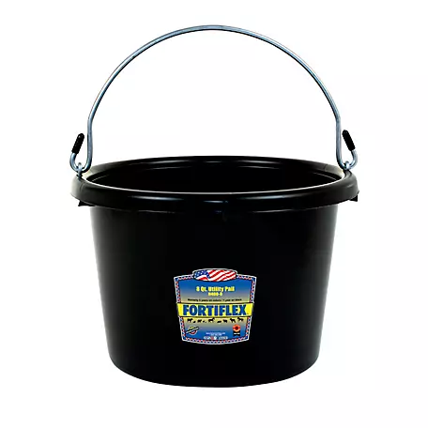

Coastal Hay – make sure the hay is clean: no stickers, twigs, etc; you can buy from local hay producer or Tractor Supply has the option below. You will only need one bale.

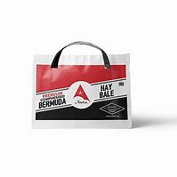

**Cleaning Supplies** – Stiff-Bristled Brush, broom/dustpan, 5-gallon bucket, dawn dish soap, mild disinfectant

**Grooming Supplies** - dawn dish soap, antifungal shampoo, Curry comb (goats), Slicker brush (lambs)

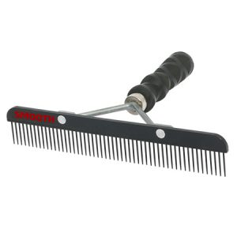 Curry Comb

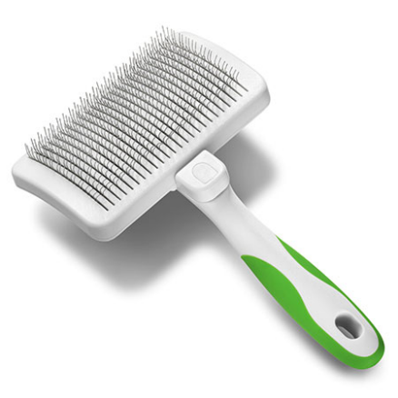 Slicker Brush

**Recommended Feed:** (best to good); you want a feed that is 13-16% Protein, Fat content will vary based on animal needs, ALWAYS make sure the feed contains Ammonium Chloride to prevent urinary blockage.

Sheep:

1. Jacoby Alpha-Sheep (textured)
2. High Noon- Charmasson Gold -OR- Show Lamb Extreme (textured)
3. Excel - 15% Ramsey Show Lamb and Goat
4. Purina

Goats:

1. Jacoby Alpha-Goat (DO NOT FEED TO SHEEP)
2. Excel - 15% Ramsey Show Lamb and Goat
3. High Noon – Silver Bullet
4. Purina

** ALWAYS MAKE SURE THE FEED IS FRESH**